**Do you think EV’s will be able to give competition to the petrol & Diesel vehicles?**

**MARKET ANALYSIS**

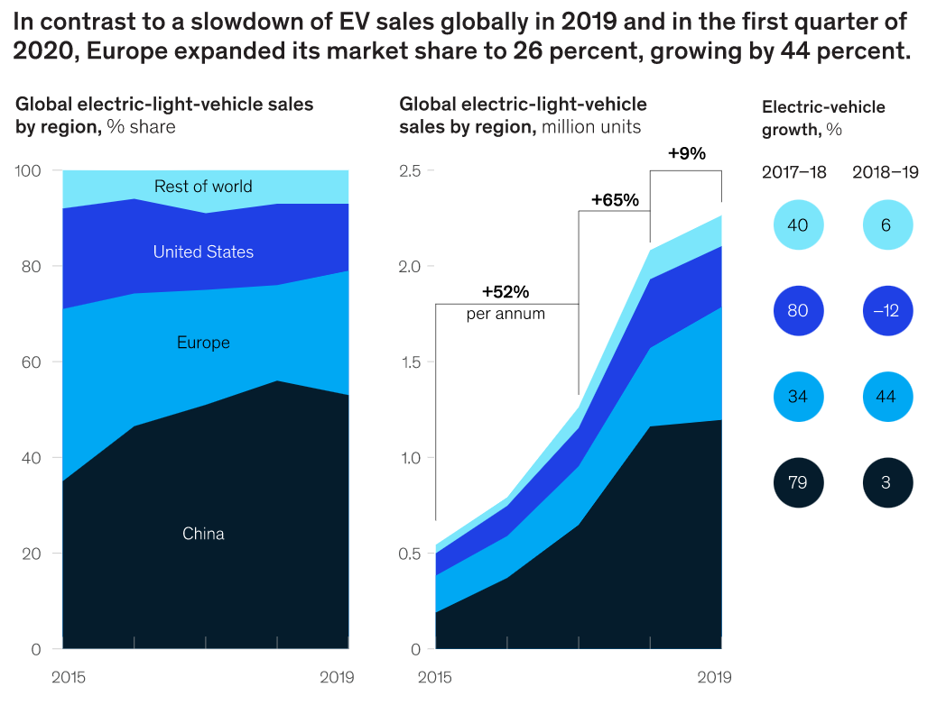

Source: [1] McKinsley & Company (July 2020)

Main EV markets suggest shifting regional dynamics, with China and the US falling behind Europe.

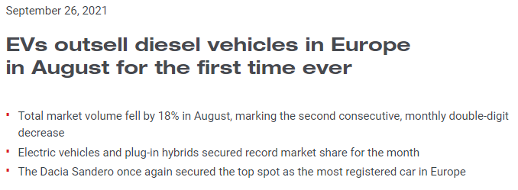

This is a recent and significant milestone in the growth of EV’s.

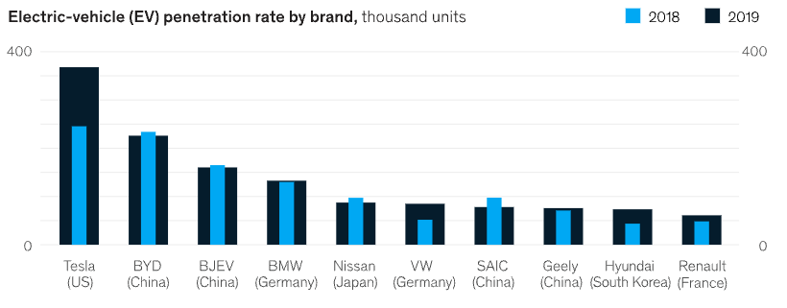

Source: [1] McKinsley & Company (July 2020)

Tesla increased its global market share to about 16 percent in 2019, with the model 3 accounting for 13 percent of sales.

Growth of EV’s:

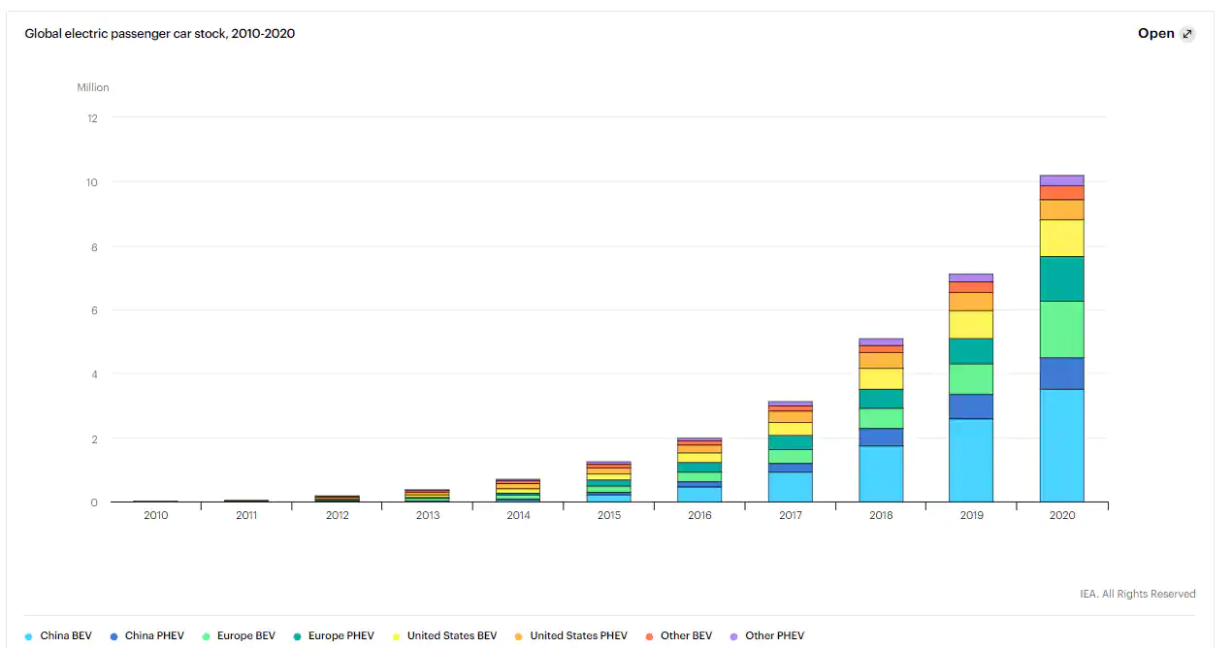

Source: IHS Markit

The rapid increase in the number of EV’s sold can be easily seen from the above graph. There are multiple factors that are responsible for his increment. Some of the major ones are:

* Improvement in the EV technology
* People have become more conscious about clean energy.
* Vast difference in the daily running costs due to high fuel price.

**COMPARISON**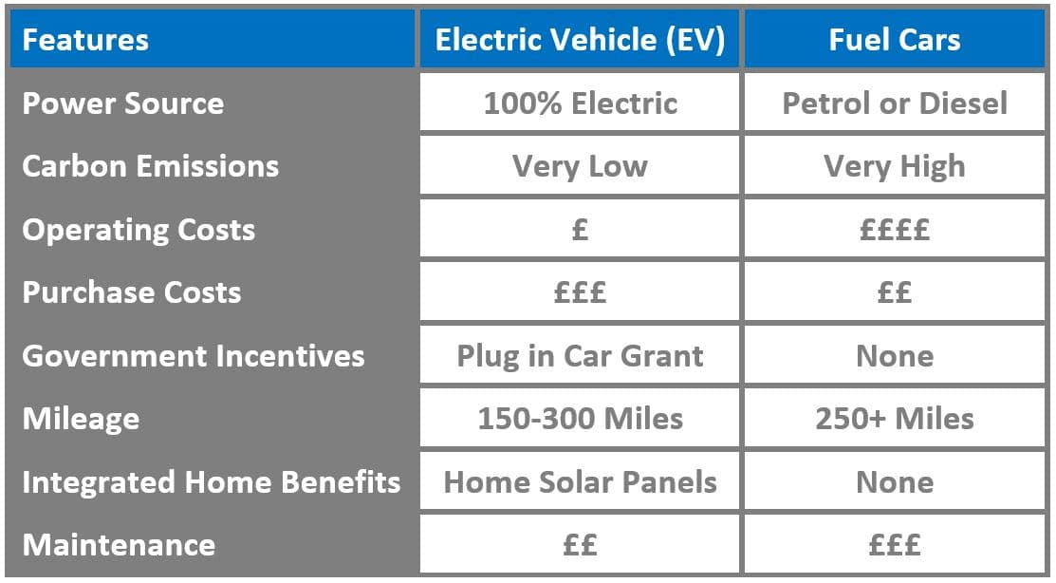

Source: Mantis Energy

The chart above shows that EV’s are equivalent or better than petrol cars in almost all features. The only place where it falls behind is the higher initial cost of purchasing but this gap is reduced by subsidies given by governments in an effort to promote green energy.

**Are EV’s worth shelling out the initial higher cost?**

**COST ANALYSIS**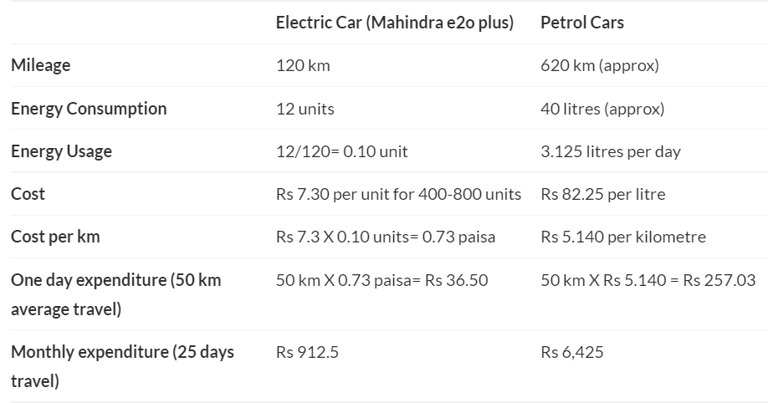

Source: Google Images

There is a significant difference in the daily running costs which can be easily seen above. Another point to be mentioned is that the petrol cost has increased significantly since this comparison while the electricity cost has increased by a minor amount only.

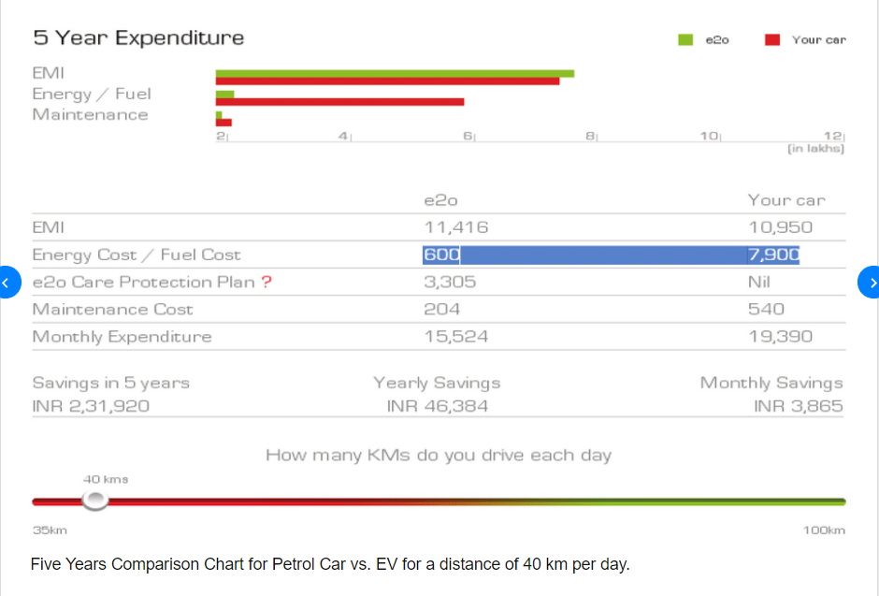

Source: Google Images

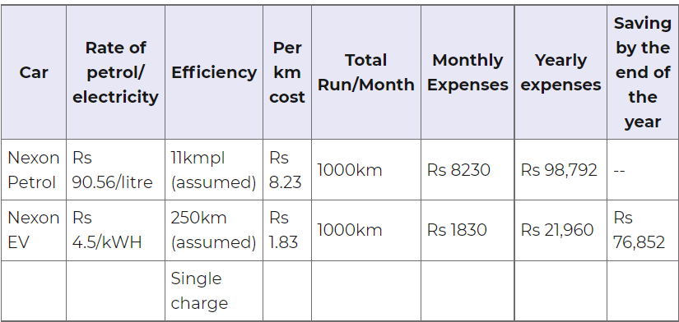

Here we have compared two categories of cars and have seen the cost differences.

Tata Nexon Petrol Variant costs INR 11 lakhs while the Nexon EV costs 14 lakhs. The price difference of 3 lakhs is easily recovered within a period of 4 years.

**REFERENCES**:

[1] <https://www.mckinsey.com/industries/automotive-and-assembly/our-insights/mckinsey-electric-vehicle-index-europe-cushions-a-global-plunge-in-ev-sales>

